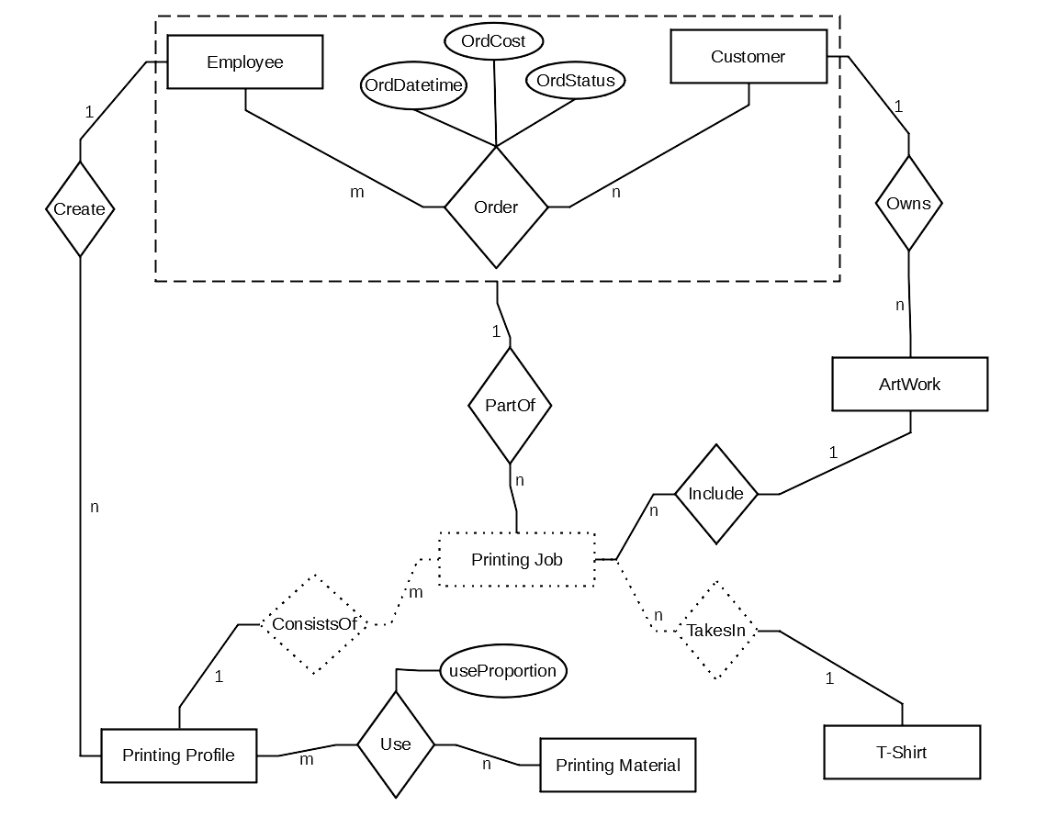

|  |  |  |  |
| --- | --- | --- | --- |
| # | Entity Name | Attributes | Entity Description |
| 1 | Customer | * cusID: (auto gen; unique). * cusName: * cusPhone#: * cusEmail: | The customer parsing the order |
| 2 | Employee | * empID: (auto gen; unique). * empName: * empEmail: | The employee taking care of the order |
| 3 | Printing Profile | * proID: (auto gen; unique). * proName: * proMode: {B&W, Colored} * proSize: {Small, Medium, Large} * proPosition: {Front, Back, Sleeves} * proDescription: * proTime: Time needed for one print of the printing profile * proPrice: Employee estimated price for the printing profile | Created by the Employee |
| 4 | Printing Job | * jobQuantity: Number of prints for this job. * jobUnitPrice: (derived). = tshPrice + proPrice. * jobTotalCost: (derived). = jobUnitCost*jobQuantity. * jobInstructions: Additional instruction from customer. | Weak entity |
| 5 | ArtWork | * artID: (auto gen; unique). * artName: * artImage: Name of image file provided by the customer. |  |
| 6 | Printing Material | * matProduct#: (unique) * matName: [e.x. Red ink…] * matAmount: (Dynamic) |  |
| 7 | T-shirt | * tshProduct#: (Unique) * tshBrand: * tshAmount: * tshSize: * tshPrice: |  |

|  |  |  |  |
| --- | --- | --- | --- |
| # | Relationship | Entities Related | Description |
| 1 | Order | Customer to Employee | * A Customer make Orders to many Employees. * An Employee can take Orders from many Customers. |
| 2 | PartOf | Printing Job to Order | * A Printing Job can be part of a single order. * An Order can be can have many Printing Jobs. |
| 3 | Create | Employee to Printing Profile | * An Employee Can Create many Printing Profiles. * A Printing Profile can be Created by a Single Employee. |
| 4 | Owns | Customer to Artwork | * A Customer Owns many Artworks. * An Artwork can be owned by a single Customer. |
| 5 | Include | Artwork to Printing Job | * An Artwork can be included in many Printing Jobs. * A Printing Job can include a Single Artwork. |
| 6 | TakesIn | T-Shirt to Printing Job | * A T-Shirt is taken for many Printing Jobs. * A Printing Job takes in a T-Shirt. |
| 7 | ConsistsOf | Printing Profile to Printing Job | * A Printing Profile constitutes many Printing Jobs. * A Printing Job consists of a single Printing Profile. |
| 8 | Use | Printing Material to Printing Profile | * A Printing Material is used for many Printing Profiles. * A Printing Profile uses many Printing Material. |